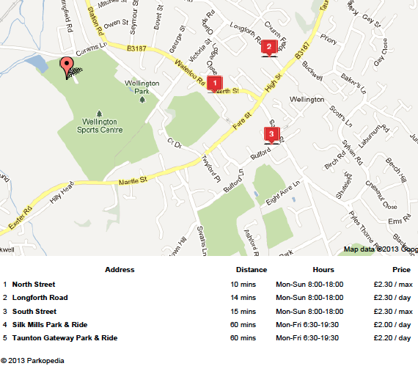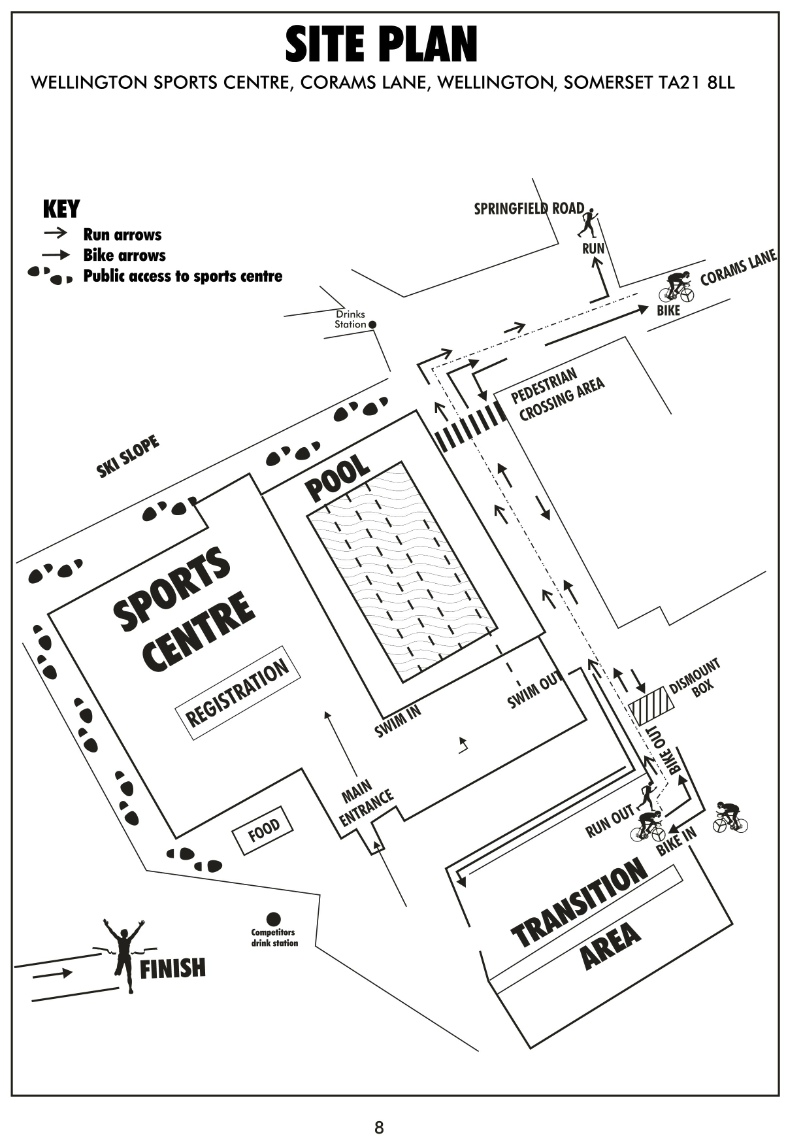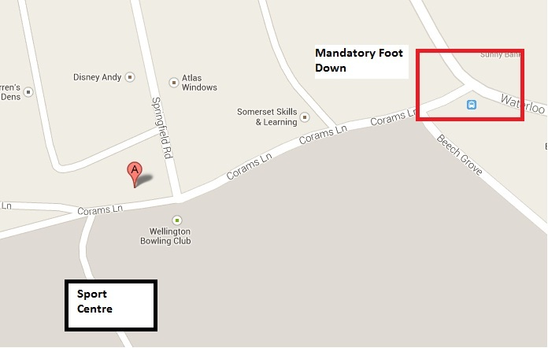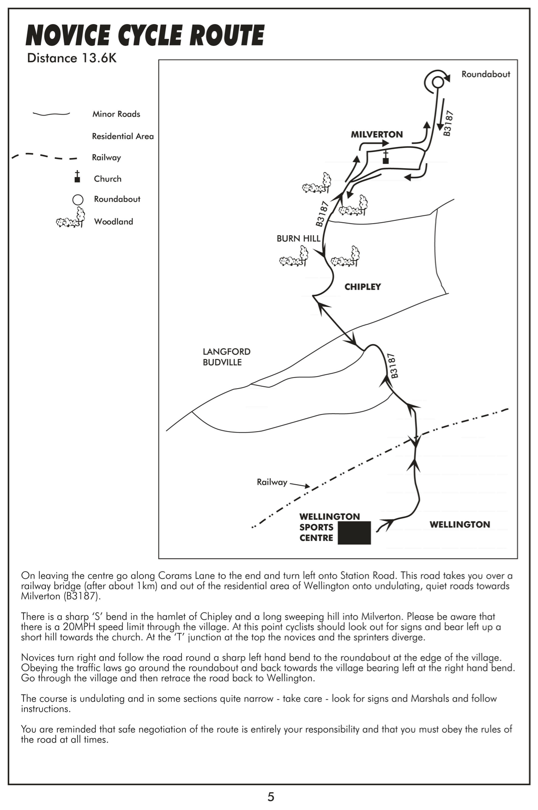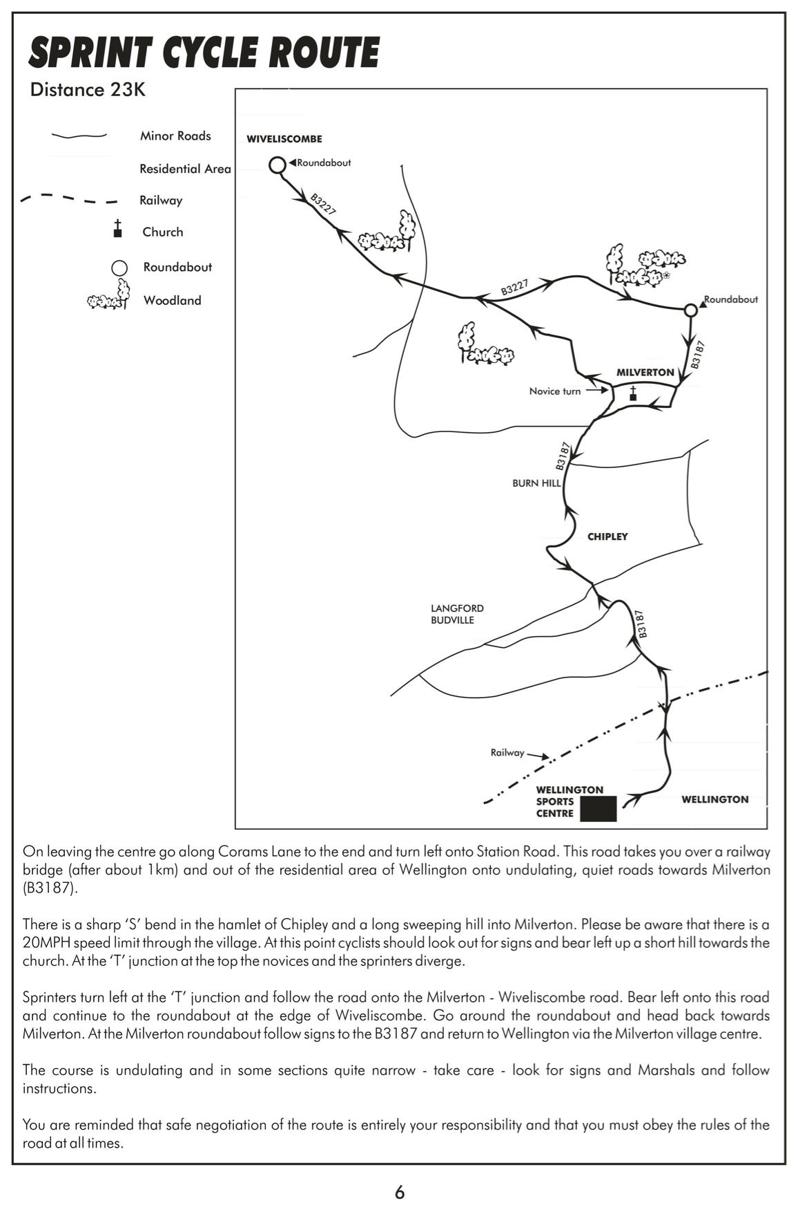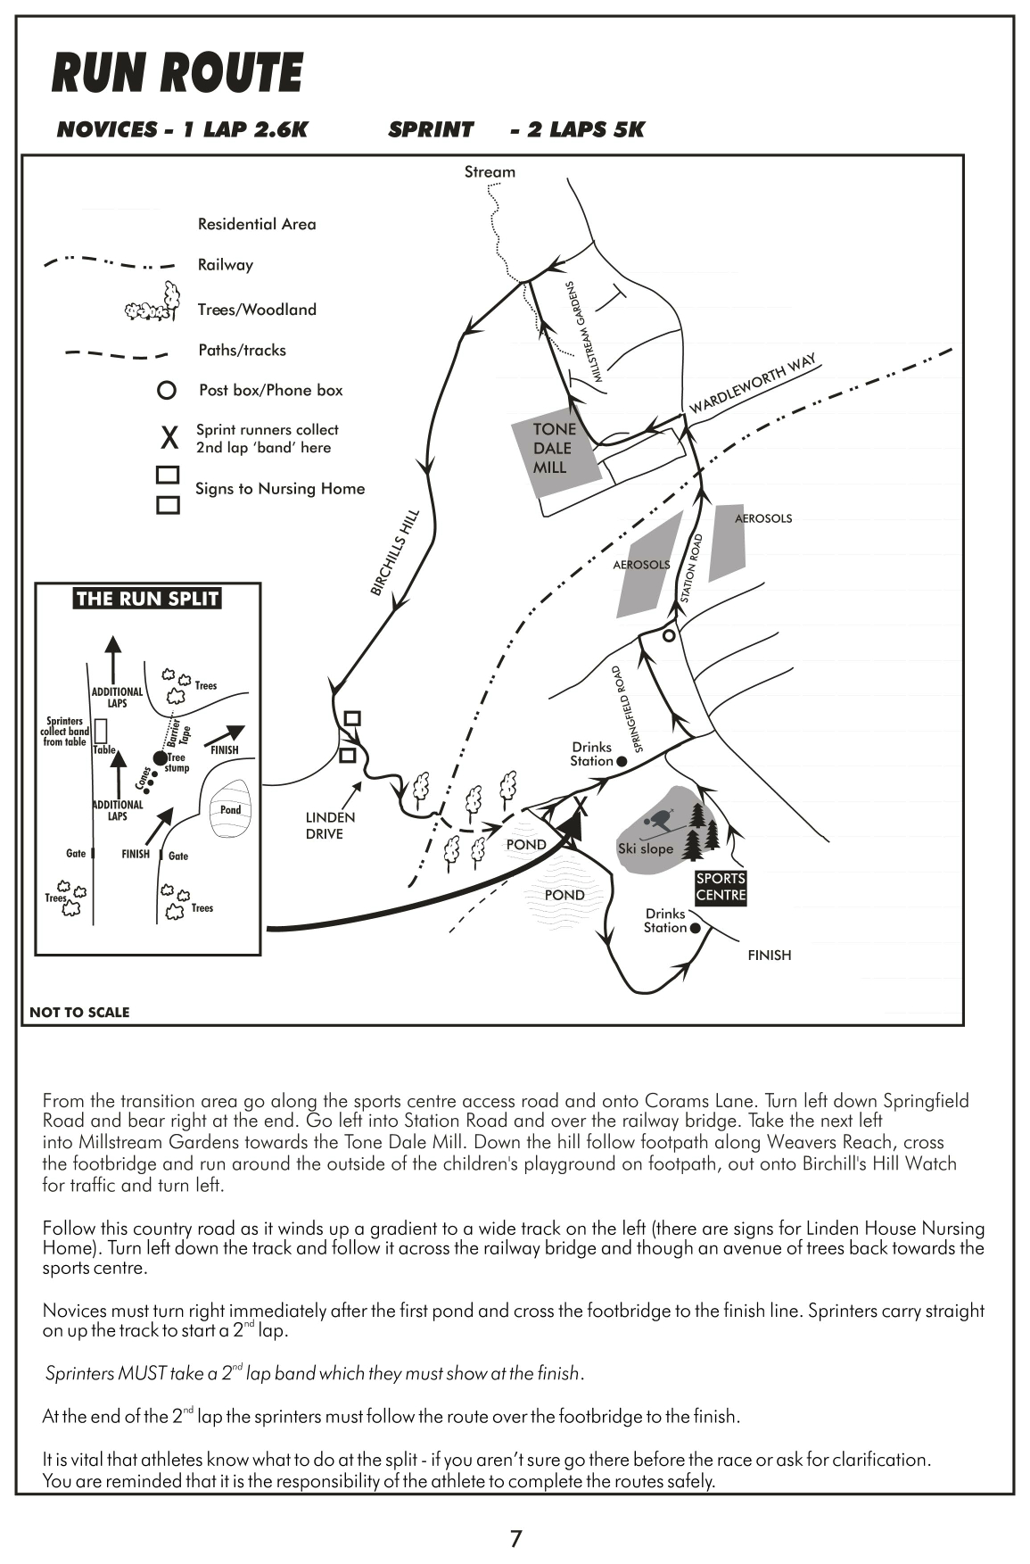site plan 2.tiff

Thank you for entering the Taunton Deane Triathlon 2020. This event is brought to you by Somerset RC Tri Club and is sponsored by Bridgwater & Taunton College. You should find all the details you require for the race in this pack, however if you have any further queries you may contact: [race_director@somersetrctri.co.uk](mailto:race_director@somersetrctri.co.uk)

We are a not for profit local club who want to encourage triathlon to all. Our entry cost is set based on costs for running this event that requires some road management and signage (the Council charge a lot for this!), hire of the Sports Centre now it’s a private company, quality timing, good prizes, proper technical vests, lots of marshalls and clear signage and above all a great race experience for all abilities. Entry includes a free training half day.

The Taunton Deane Sprint and Novice Triathlon

12th July 2020

RACE INFORMATION PACK

Taunton Deane Triathlon

**www.somersetrctri.co.uk**

**Wellington Sports Centre**

**Corams lane, Wellington**

**Somerset, TA21 8LL**

**Registration:**

Will take place in the Main Hall of the Sports Centre (access through the side fire doors or through the main reception) between 8:30am and 11.00am. Competitors who have not registered by 11.00am will forfeit their places.

On arrival please look up you race number from the entrants list before approaching the registration desk. You will then tell the staff your race number, confirm your name and show your BTF race license, if applicable (day licenses will be issued to those who entered as “non-BTF”). IMPORTANT: If you are a youth aged 15-16 you require parental consent to race. If a parent/guardian is present on the day they can provide consent. If you will be alone you require written consent which you must provide at registration.

**Race Pack:** You will be given a race pack containing:

* 1x Race numbers: which must be worn on the front during the run. Race belts are permitted and you may wish to wear the number during the bike portion – in which case it should be visible from behind. It is the athletes responsibility to ensure that numbers are turned the correct way and clearly visible throughout the race.
* 2x Sticky labels: one for the front of your cycle helmet and the other must be attached around the seat post of your bicycle.
* 1x Security wrist band which allows you access into the secure transition area. Non competitors will not be admitted.
* 1x Event T shirt, size according to that requested on your entry form.

IMPORTANT: Please write your full name, an emergency contact number and make a note of any medical conditions that may be important in the event of an accident on the back of your race numbers (e.g.: asthma, epilepsy, insulin dependent diabetes, severe drug allergies etc).

**Timing Chip:** You will be given a timing chip to wear throughout the race (you will be given instructions on how to wear this). CHIPS WILL BE HANDED TO YOU AT POOLSIDE, just before the start of your race. The chip must be returned at the end of the race, K2 timing reserve the right to charge the cost of any lost or unreturned chips. We pay to use a specialist timing company so that you can have a paper record of your race including swim, T1, bike, T2 , run and overall times which you can print at the finish of the race. It even tells you your race position as at the time you finished.

**Bike Racking:** Having applied the numbered stickers, take your bike to the Transition Area and hang it on the rack in the space allocated to you, which will be marked with your race number. **All bikes must be racked by 11am**.

**Helmets are compulsory for this race**. NO HELMET=NO RACE. Helmets should be free from physical defects and have secure fastening. Helmets will be checked for obvious flaws at the entrance to transition when you come to rack your bike and any helmet not deemed to be in a safe condition will not be accepted. If you have any concerns about your helmet – attend to it prior to race day! (come to the free training day and we can check your equipment for you)

Your running gear should be neatly arranged close to your bike space – any other bags or clothing should not be left here as it may be a hindrance to other athletes. It is not permitted to “mark” your spot in any way , however the racks will be labeled with Letters or coloured balloons to help you to remember where it is!

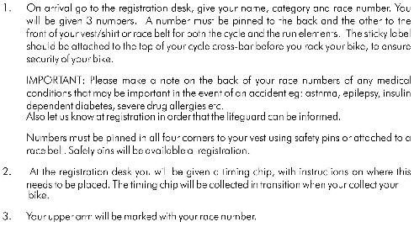



**MANDATORY RACE BRIEFINGS**

Will be held on poolside 10 minutes prior to the start of each wave. Here you will be notified of any late changes to the race courses and reminded of the race rules and procedures. ALL ATHLETES MUST ATTEND.

**GENERAL NOTES**

1. Breaking of any BTF rules/instructions may result in disqualification. As a BTF registered event there will be a BTF paid representative who checks that all rules are adhered to.
2. There will be a race briefing at pool side 10 minutes prior to the start of each wave - attendance of this is mandatory for all competitors.
3. The decision of the Race Director in the event of any dispute is final.
4. Race numbers must be worn as previously indicated. The course marshals must be able to see your number so make sure they are worn correctly, pinned top and bottom or securely attached to a race belt. Your bike sticker should be visible from either side and not obscured by saddle bags or any other items.
5. Approved cycle helmets (with a safety standard mark) must be worn. No helmet= No race.
6. Competitors are entirely responsible for the road-worthiness of their bicycle. We highly recommend that you give you bike a thorough check over and if necessary it serviced before the race.
7. Every effort will be made to clearly mark and marshal the run routes but we must emphasise that it is the responsibility of the competitor to negotiate the route correctly and safely.
8. No physical assistance of any sort is allowed at any point during the Triathlon (with the exception of certain categories of disability, by prior arrangement with the race director)
9. Any competitor “dropping out” is required to report back to race officials at the race reception area and return their timing chip.
10. Supervision of the transition area will be in place from 8:30am and stand down a few minutes after the last competitor has finished their race. Only competitors will be allowed entry to this area, athlete wrist bands will be issued at registration for identification. We appreciate the value of your kit and protect it.

.

1. Most importantly – enjoy your day!

**HOW TO FIND US**

The address of the venue is:

**Wellington Sports Centre, Corams Lane, Wellington, Somerset , TA21 8LL**

Take Junction 26 off the M5 sign-posted A38 Wellington.

At the roundabout take the A38 exit to Taunton and Wellington.

At the next roundabout take the second exit for Wellington 83187.

After about a mile, at the first set of traffic lights in Wellington, turn right into Longforth Road. Directly after the "green" on the left hand side turn left into Victoria Street.

At the T Junction turn right to join Waterloo Road, and then take a left turn into Coram’s Lane.

**There is NO PARKING available at the Sports Centre during the event.**

Corams Lane and Springfield road, adjacent to the sports centre will form parts of the race courses and will be inaccessible to vehicles between 9am and 3pm. For the safety of competitors we request that you do not park in these streets. Spaces may be found on Waterloo road, additionally Wellington has several inexpensive public car parks within easy walking distance of the Sports Centre – we advise that you make use of these.

**THE RACE**

**SWIM SECTION**

The **swim** will take place in the indoor, heated 25m pool at Wellington Sports Centre**.**

**Novice distance will swim 200m (8 lengths)**

**Sprint distance will swim 400m (16 lengths).**

1. Please be at the swim start ready to swim **10 minutes** before your allocated start time for the race briefing
2. Enter pool hall only when asked to do so by the pool supervisor
3. You will be instructed as to which lane to use and in which direction to swim
4. You will be given your race timing chip, which is to be worn for the whole race and returned after the finish.
5. You will be given a swim cap that must be worn throughout the swim so that you can be identified by your lane’s lap-counter. Please hand this to a marshal on leaving the water.
6. All competitors start in the water. No diving. (and no nudity 😊)
7. Overtaking may take place in the middle of the lane. Alternatively, you may touch the foot of the swimmer in front, and he/she is then compelled to let you overtake at the end of that length.
8. If you plan to tumble turn please be aware of the handrails at either end of the pool, as well as the possible presence of other swimmers in your lane.
9. No swim aids, flippers, wet suits etc may be used. Goggles and nose clips may be worn.
10. No backstroke or butterfly is permitted.
11. Any swimmer who swims in a dangerous manner or in a way that impedes another swimmer may be disqualified after one warning from the swim judges.
12. "2 lengths to go" boards will be put into the water at the appropriate time for all competitors to note. Do not exit the pool until you have done 2 lengths after the board. **You may have counted differently! – don’t argue until after the race when you can challenge with the race director based on evidence that you completed too many lengths.**
13. On completing the swim section, competitors leave the water and make their way to their bike spot in the transition area. As always ‘don’t run poolside’ and outside please be safe especially if it is wet. We put out some matting but it can be slippery if it is raining (we have ordered sun 😊).

**Please note that your estimated swim time determines which ‘wave’ you are in so that we have swimmers of similar ability swimming in the same lanes to minimise the need for overtaking.**

1. There is a mandatory **FOOT DOWN** rule in place at the junction of Corams Lane and Waterloo Road. This applies to all competitors in both races and is in place for your safety. Please refer to the detail on the next page.

**SWIM TO BIKE TRANSITION**

1. Change into your cycling kit in the transition area.

1. You must **put on and fasten** your bike helmet **before** you remove your bike from the rack. You will not be allowed out of transition without your helmet securely fastened and your race numbers clearly visible.

1. No assistance is permitted in the transition area.
2. No nudity is permitted in the transition area.
3. Push your bike out of transition, taking care of other athletes as you do so, and into the “Bike Mount” area. Here you will get on your bike and progress onto the bike course. Note you can mount whenever you like as long as it is AFTER the mount start area.

**MANDATORY FOOT DOWN** **at the junction of Corams Lane and Waterloo Road.**

This applies to all competitors in both races and is for your safety.

On your way OUT onto the bike course when turning from Corams Lane, which will be closed for the race, onto the “live” through-road where passing traffic has right of way, you are required to come to a complete stop, and place one foot on the ground –check for traffic – before proceeding. This is marshalled and you will be told when to ‘go’. Usually this is seconds but if there is traffic it can be longer – don’t worry – unlike most open road tri’s we have timing mats here and deduct your waiting time 😊

On your RETURN to the sports centre, the right turn back into Corams lane requires that you cross “live” oncoming traffic on Waterloo road. You are once again required to come to a complete stop, place on foot on the ground, checking for traffic before proceeding. Marshals cannot stop traffic.

This rule applies even if you judge that the road is clear of traffic. Our chip timing technology allows us to determine the exact time that you were held at this junction. That time will be deducted from your bike split – therefore it is of NO benefit to break this rule! Marshals and a race referee will be stationed at this point to ensure that all competitors adhere to this rule, and failure to do so will risk disqualification.

**BIKE SECTION**

The **bike** route is a moderately technical course on a mix of quiet country lanes, fast level sections, tight bends and a few hills. Take care at all times

**Novice distance will ride 13.6km -**refer to route map

**Sprint distance will ride 23km -** refer to route map

The Novice distance turns back towards Wellington when they reach Milverton, Sprint distance continues on towards Wiveliscombe. Both sets of cyclists should know their route and look and listen for directions from marshals and signage in Milverton.

Competitors are entirely responsible for the roadworthiness of their bikes. You are advised to carry tools necessary to repair a puncture with you. No Accompanying vehicles are allowed on the course and anyone receiving assistance will be disqualified.

* Helmets must be worn and properly fastened throughout the entire bike section
* The majority of the course is on open public highways. The rules of the road must be obeyed, this includes any speed restrictions, STOP or GIVE WAY signs, road traffic priority and generally “cycling with due care and attention”. You must also follow any additional instructions given to you by police or race marshals – these will be for your own safety, or that of another competitor/road user.

* The race organizers accept no responsibility whatsoever for the conduct of competitors on public highways. Please be a good representative of our sport and be considerate to other road users and pedestrians.
* This is a “Non-Drafting” race – slipstreaming is not allowed. There should be 10 meters between cyclists, except when overtaking. An overtaking move must be completed within 30 seconds. Anyone caught by a faster rider must drop back once the overtaking rider’s front wheel has passed theirs. Anyone caught in breach of these rules will receive one warning before disqualification
* Keep well to the left at all times – crossing the centre of the road will lead to disqualification. Allow faster riders to pass safely on your right. NO overtaking on the inside.
* Turns will have a marshal and signs. Our marshals may shout warnings but can NOT stop traffic for you, it is your responsibility to check that the road is clear.
* You must dismount in the “Dismount Box: and push your bike into the transition area. You will replace your bike in your spot and then remove your helmet and change into your run kit. Note: Helmet must remain secured until your bike has been racked.

In the event on un-repairable mechanical failure which means you’re unable to compete the bike route, we do have a “rescue” vehicle that will collect you .You are to inform (or ask a passing competitor to) the nearest marshal of your race number and location and await pick up. Marshals on route have foil blankets for warmth, and possible a nearby car in which you can keep warm.

Google Maps Link for Novice Bike Route:

https://www.google.com/maps/d/viewer?mid=z6rLr_ai56VY.klaA8j8y6FXE&ie=UTF&msa=0

Google Maps Link for Sprint Bike Route:

https://www.google.com/maps/d/viewer?mid=z6rLr_ai56VY.klnNU_3sdLFk&ie=UTF&msa=0

**BIKE TO RUN TRANSITION**

1. Change into your run kit in the transition area. Make sure that your numbers are secure and visible from the front.
2. Leave your cycling gear near your bike.
3. Take care as you exit transition and be aware of other athletes passing through
4. No assistance is permitted in the transition area (with the exception of certain categories of disability, by prior arrangement with the race director).
5. No nudity is permitted in the transition area.

Google Maps Link for Run Route (1 Lap):

https://www.google.com/maps/d/viewer?mid=zuUFNnSkqbMo.kqs5XFg6OAU8&hl=en&ie=UTF8&msa=0&t=h&ll=50.982508,-3.243657&spn=0.008727,0.019226&z=16

**RUN SECTION**

The **run** route loops through a mix of residential streets, foot paths and quiet country lanes, with a few hills. Take care at all times

**Novice distance will run 2.5km (one lap) -**refer to route map

**Sprint distance will run 5km (two laps) -**refer to route map

1. No assistance or "pacing" is allowed. Infringement will lead to disqualification.
2. Running vests/tops must be worn at all times
3. Your race number must be clearly visible on your front. Number belts are permitted.
4. Marshalls and signs will be placed at all junctions/turns
5. Competitors must obey any directions from the police/marshalls at all times
6. Mp3 players/personal stereos etc are not permitted
7. Corners must not be cut – where cones or barrier tape have been laid out, runners must go around. Failure to do so will result in disqualification
8. Competitors in the Sprint race will run 2 laps and must collect (and wear) a band from the marshal at the end of the first lap. Failure to wear the band through the finish line will result in disqualification.
9. Drinks stations are available at the start of the second lap and at the finish, as indicated on the route maps.

**PRIZE CATEGORIES**

The fastest competitor (regardless of category) in the Men’s Sprint and Women’s’ Sprint race will be awarded a £50 prize each.

The time given freely by our club members in hosting this event, enables us to offer generous CASH prizes for these top finishers in the Sprint Triathlon.

The age-group winners in BOTH the Sprint and the Novice triathlon will receive locally made customised trophies for this year’s event.

Awards will be given subject to the number of starters* in the category:

1-9 competitors - 1st

10-15 competitors - 1st and 2nd

15+ competitors - 1st, 2nd , 3rd

*(at the time of placing the order, 2 weeks prior to race)

**AFTER THE RACE**

1. There will be drinks at the finish line
2. Changing and showers are available in the Sports Centre and you can enjoy a complimentary post –race massage from therapists of The Crescent Clinic (www.thecrescentclinic.co.uk)
3. Collect your swimming gear and bike. Transition security will check you out on production of your race number
4. There are vending machines available at the Sports Centre for snacks and drinks and the rugby club will be serving hot drinks and food.
5. Results will be available shortly after the final competitors finish. Presentation of awards for the NOVICE race will take place in the registration hall at approximately 12:00 pm, and for the Sprint Race at approximately 2:30pm (once the final wave of competitors has completed the race)
6. Race day photography will be provided by Charles Whitton Photography, and your racing images will be available from <http://www.charleswhittonphotography.com> soon after the event.

**FOR SPECTATORS**

Whilst there will be no spectators allowed poolside, you’ll be able to watch the swim through the viewing window into the pool. You’ll get a great view of cyclists departing and returning from their bike portion from Corams Lane, and will see runners on passing on the two lap course from various vantage points in the park around the rear of the sports centre – we encourage you to get out and give them a cheer!

**REFRESHMENTS** are available from vending within the sports centre, club members have been “Baking Off” and the produce and cold drinks will be on sale in the registration hall, and hot drinks and food are being served up by Wellington Rugby Club (adjacent the sports centre). There should also be a van selling hot food and drinks and an ice cream van.

TRANSITION

BIKE AND RUN EXIT

SITE PLAN

